Table of Contents

1,Check soft package 1

2,Configure the configuration file of multipath 3

2.1,find the configuration file and copy the configuration file to /etc/ directory. 3

2,2,confirm server local disk label 3

2.2,modify the configuration file with /etc/multipath.conf 3

3,start multipath service and set multipath enable when server start. 5

4,set HBA storage be right,and reload the new HBA storage. 5

5,Set HBA storage disk alias 5

6, Let the alias to take effect. 6

# 1,Check soft package

Execute command as following：

rpm -q device-mapper

rpm -q device-mapper-event

rpm -q device-mapper-multipath

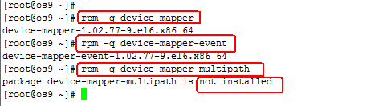

As we saw,the package device-mapper-multipath has not been installed,so we should install this package now,

Execute command as follows：

yum install device-mapper-multipath

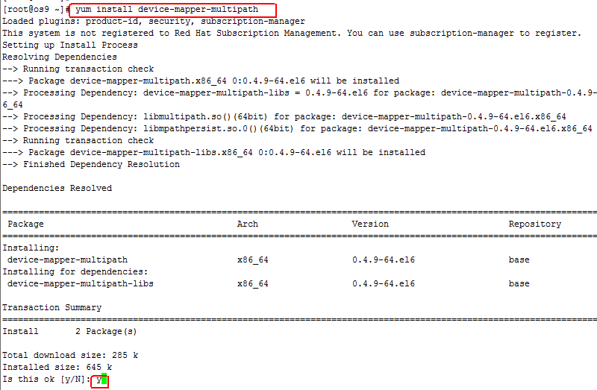

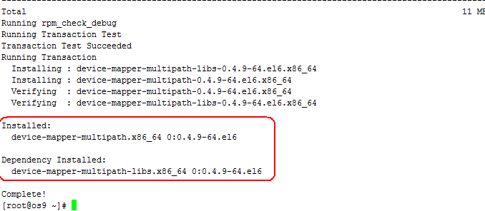

Installation has been complete.

# 2,Configure the configuration file of multipath

## 2.1,Find the configuration file and copy the configuration file to /etc/ directory.

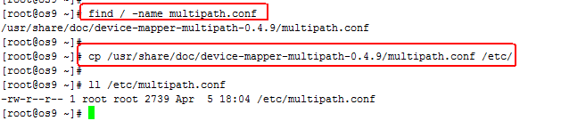

## 2,2,Confirm server local disk label

lsblk

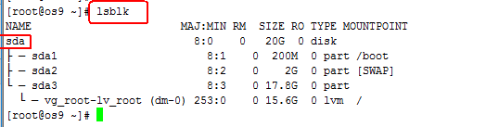

Ok，I find the server local disk is sda.I will write it into configuration file in the next step.

## 2.2,Modify the configuration file with /etc/multipath.conf

vim /etc/multipath.conf



Set line number

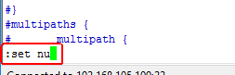

We should change the three places,

In the first place as follows:

Before change

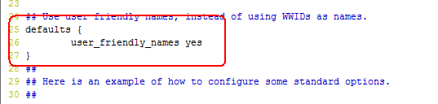

After change

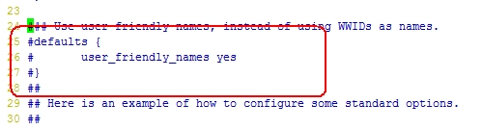

The second place as follows:

Before change

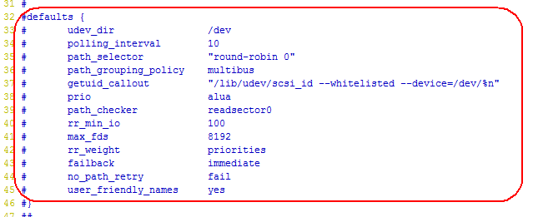

After change

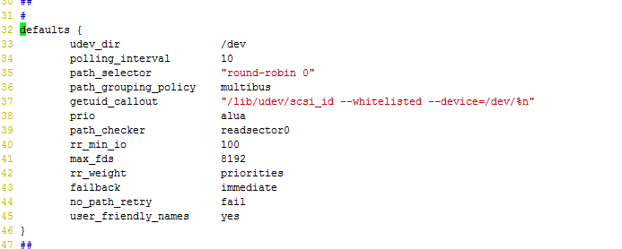

The third place as follows:

Before change

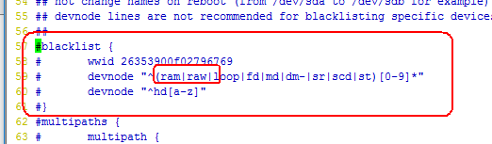

After change

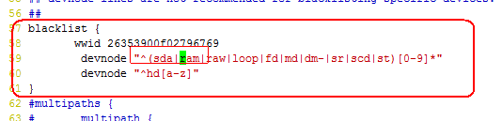

With save and quit.

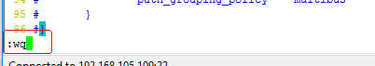

# 3,Start multipath service and set multipath enable when server start.

/etc/init.d/multipath start

chkconfig --level 345 multipathd on

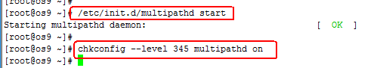

# 4,Set HBA storage be right,and reload the new HBA storage.

When the HBA storage has set been right,we should be execute command as follow:

modprobe -r lpfc

modprobe lpfc



# 5,Set HBA storage disk alias

If we have multiple server,that maybe we need set the disk alias of HBA storage.

Check HBA storage informations,execute command to as follow:

multipath -ll

If HBA storage has set be right,that after execute “multipath -ll”,we can see those disk label and their wwid,but with the different server,disk label and wwid maybe not parallelism correct.so we need set HBA storage disk alias on each server.

Now ,modify the configuration file of multipath again.

vim /etc/multipath.conf



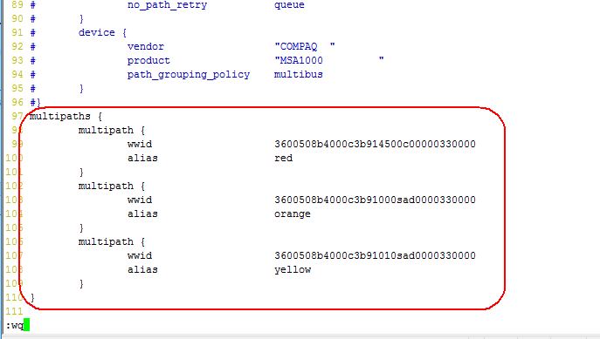

# 6, Let the alias to take effect.

Execute command as follows:

/etc/init.d/multipathd restart

multipath -F

multipath -v2

multipath -ll

when you executed “multipath -ll”,you’ll see the alias has been set completed.